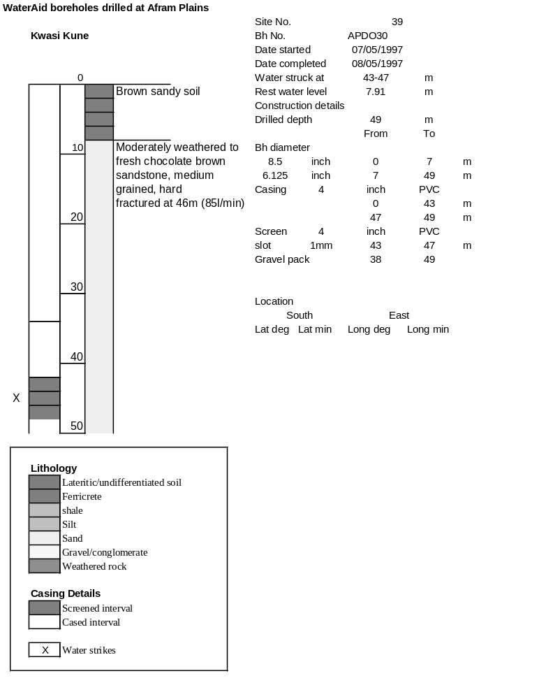

Ghana | Test pumping
Borehole No. |  | APDO 30
Hole No |  | 39
Village |  | Kwasi Kune
Date |  | 13/06/1997
Point below GL |  | 0.56 | m
Pump depth |  | 24 | m
SWL |  | 7.91 | m
Start Time |  | 20:00
Drawdown test |  |  |  |  | Recovery Test
time | pwl (m) | Q l/min | dd | sc(q/s) | Time | wl (m) | t/t' | resdd
0.00 | 7.91 | 68.00 | 0.00 |  | 0.00 | 9.57 |  | 1.66
1.00 | 8.06 | 68.00 | 0.15 | 453.33 | 1.00 | 8.14 | 111.00 | 0.23
2.00 | 8.20 | 68.00 | 0.29 | 234.48 | 2.00 | 8.13 | 56.00 | 0.22
3.00 | 8.35 | 68.00 | 0.44 | 154.55 | 3.00 | 8.13 | 37.67 | 0.22
4.00 | 8.45 | 68.00 | 0.54 | 125.93 | 4.00 | 8.13 | 28.50 | 0.22
5.00 | 8.69 | 68.00 | 0.78 | 87.18 | 5.00 | 8.12 | 23.00 | 0.21
6.00 | 8.78 | 68.00 | 0.87 | 78.16 | 6.00 | 8.11 | 19.33 | 0.20
7.00 | 8.85 | 68.00 | 0.94 | 72.34 | 7.00 | 8.10 | 16.71 | 0.19
8.00 | 8.98 | 68.00 | 1.07 | 63.55 | 8.00 | 8.10 | 14.75 | 0.19
9.00 | 9.20 | 68.00 | 1.29 | 52.71 | 9.00 | 8.10 | 13.22 | 0.19
10.00 | 9.22 | 68.00 | 1.31 | 51.91 | 10.00 | 8.10 | 12.00 | 0.19
12.00 | 9.28 | 68.00 | 1.37 | 49.64 | 12.00 | 8.10 | 10.17 | 0.19
14.00 | 9.33 | 68.00 | 1.42 | 47.89 | 14.00 | 8.10 | 8.86 | 0.19
16.00 | 9.35 | 68.00 | 1.44 | 47.22 | 16.00 | 8.09 | 7.88 | 0.18
18.00 | 9.35 | 68.00 | 1.44 | 47.22 | 18.00 | 8.09 | 7.11 | 0.18
20.00 | 9.36 | 68.00 | 1.45 | 46.90 | 20.00 | 8.09 | 6.50 | 0.18
25.00 | 9.38 | 68.00 | 1.47 | 46.26 | 25.00 | 8.08 | 5.40 | 0.17
30.00 | 9.40 | 68.00 | 1.49 | 45.64 | 30.00 | 8.08 | 4.67 | 0.17
35.00 | 9.41 | 68.00 | 1.50 | 45.33 | 35.00 | 8.08 | 4.14 | 0.17
40.00 | 9.42 | 68.00 | 1.51 | 45.03 | 40.00 | 8.07 | 3.75 | 0.16
45.00 | 9.44 | 68.00 | 1.53 | 44.44 | 45.00 | 8.07 | 3.44 | 0.16
50.00 | 9.45 | 68.00 | 1.54 | 44.16 | 50.00 | 8.07 | 3.20 | 0.16
60.00 | 9.46 | 68.00 | 1.55 | 43.87 | 60.00 | 8.06 | 2.83 | 0.15
70.00 | 9.51 | 68.00 | 1.60 | 42.50 | 70.00 | 8.06 | 2.57 | 0.15
80.00 | 9.53 | 68.00 | 1.62 | 41.98 | 80.00 | 8.06 | 2.38 | 0.15
90.00 | 9.54 | 68.00 | 1.63 | 41.72 | 90.00 | 8.06 | 2.22 | 0.15
100.00 | 9.56 | 68.00 | 1.65 | 41.21 | 100.00 | 8.06 | 2.10 | 0.15
110.00 | 9.57 | 68.00 | 1.66 | 40.96 | 110.00 | 8.05 | 2.00 | 0.14
 |  |  |  |  | 120.00 | 8.05 | 1.92 | 0.14

